**Department of Earth & Environment**

***2023 Graduate Research Symposium***

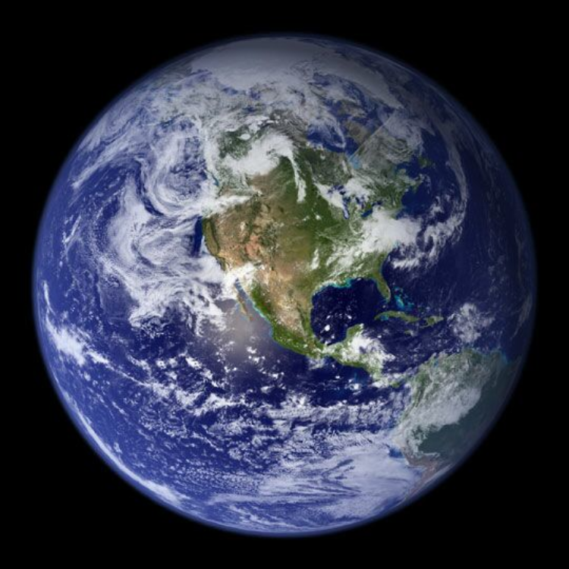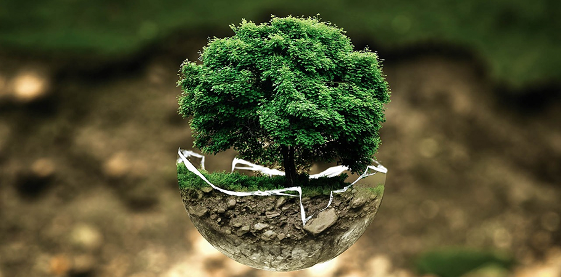

**School of Environment, Arts and Society**

**College of Arts, Sciences and Education**

**Florida International University**

**Friday, February 17, 2023**

**Location: MARC Pavilion**

Program Schedule:

**Welcome and Opening Remarks**

8:30 Mekdelawit Deribe, Lead Coordinator of the Symposium

8:35 Dr. Assefa Melesse, Graduate Program Director

8:45 Dr. Leonard Scinto, Chairperson, Department of Earth & Environment

9:00 Invited Speaker, TBD

**Graduate Student Presentations**

9:15 – 10:30 am Session 1 – Oral Presentations

10:30–11:00 am Break

11:00 – 1:00 pm Session 2 – Poster Presentations

1:10 – 1:30 pm Session 3 – 3 Minute Presentations

1:30 – 2:30 pm Session 4 - Oral presentations

2:30 – 3:00 pm Break

3:00 – 4:00 pm Session 5 - Oral presentations

**Awards**

4:00 – 4:30 pm Judges deliberate

4:30 – 5:00 pm Presentation of awards for best posters and best talks

|  |  |  |  |  |
| --- | --- | --- | --- | --- |
| **Session 1 – Oral Presentations (9:15 - 10:30)**  **Moderator: Cody Eggenberger** | | | | |
|  | | | | |
| **Time** | | **Name** | **Program** | **Presentation Title** |
| 09:15 | | Moses | PhD | Assessment of Ground Water Quality in Bwaise Slum, Kampala District for Domestic Usage |
| 09:30 | | Ikechukwu (Ike) Onwuka | PhD | Particulate and Phosphorus Dynamics in the Water Column and Sediments of Greater Everglades Ecosystem Canals |
| 09:45 | | Jazmin Locke | PhD | Phytoremediation with Cut-Flowers on Floating Treatment Wetlands (FTW) in South Florida |
| 10:00 | | Himadri Biswas | PhD | Spatial distribution pattern of Rhizophora mangle in Southeast Saline Everglades |
| 10:15 | | Anurag Sharma | PhD | Monitoring Coastal Subsidence in Southeast Florida Using Sentinel-1 InSAR Time Series Observations |
| **Coffee Break 10:30-11:00** | | | | |
| **Session 2 – Poster Presentations (11:00-1:00, with first authors present)**  **Moderators: Mason Bradbury and Miguel Valencia** | | | | |
|  | | | | |
| **Name** | | | **Program** | **Poster Title** |
| Ikechukwu (Ike) Onwuka | | | PhD | Estimation of High-Resolution Suspended Solids and Particulate Phosphorus using Acoustic Devices in a Hydrologically Managed Canal in South Florida, USA |
| Jordan Prats | | | PhD | Evaluation of the Effect of Harvesting Time on Three Varieties of Industrial Hemp (Cannabis Sativa L) |
| Priyanka Belbase | | | PhD | Monitoring the Growth, Physiology and Production of Dragon fruit in a high tunnel facility |
| Vagheeswari | | | PhD | Development of electrochemical sensor for detecting macro-nutrients in soil |
| Jessica Dominguez | | | PhD | Endophytes and Plant Extracts as Potential Antimicrobial Agents Against Candidatus Liberibacter asiaticus, Causal Agent of Huanglongbing |
| Tania Islam | | | PhD | Drought vulnerability assessment in California |
| Ethiopia Bisrat Zeleke | | | PhD | The Role of Global Climate Indices in Predicting Seasonal Rainfall Magnitude in Ethiopia |
| Blaire Kleiman | | | PhD | Heat Stress Effects on Tomatoes and Bumblebees |
| Daphne Sugino | | | PhD | Effects of Compost teas on Turmeric Growth |
| Jonathan Rodemann | | | PhD | Development of a continuous depth-invariant vegetation index for mapping seagrass cover |
| Denise Garcia | | | PhD | Analyzing the Geophysical Properties of Groundwater at the Everglades National Park using Electrical Resistivity Methods |
| Dafrosa John Kataraihya | | | PhD | Investigating the effects of wind azimuth and magnitude on sea level rise along the US Atlantic and Gulf of Mexico |
| Brandon Sosa | | | PhD | Valuing the Use of Grazers as a Tool for Enhancing Coral Reef Restoration |
| Lauren DeVito | | | PhD | The effects of projected sea-level rise on the carbon balance of collapsing sawgrass peat marshes |
| Chloe' Vorseth | | | PhD | Tight Lines and Survey Designs: Estimating the Recreational Economic Value of Lake Okeechobee |
| **Session 3 – Three Minute Theses (1:10-1:30 pm).**  **Moderator: Vanessa Londono** | | | | |
|  | | | | |
| **Time** | **Name** | | **Program** | **Presentation Title** |
| 1:10 | Tania Romero Bautista | | PhD | Freshwater Policies in the Peruvian Amazon: Historical Analysis and Policy gaps |
| 1:15 | Gabrielle Gray-Case | | MS | Approaches to the linkage between language and ecology, and potential research pathways |
| 1:20 | LuLu Victoria-Lacy | | PhD | More than food: the cultural contributions of fish and other aquatic beings in the Amazon Basin |
| 1:25 | Yohannes Ogbandrias | | PhD | Coastal subsidence along the Red Sea coast of Assab port |
| **Session 4 – Oral Presentations (1:30 – 2:30 pm)**  **Moderator: Ikechukwu (Ike) Onwuka** | | | | |
|  | | | | |
| **Time** | **Name** | | **Program** | **Presentation Title** |
| 1:30 | Lauren Emer | | PhD | Rethinking contaminant control: A case study of hydrocarbon exposure risk and Amazonian freshwater systems |
| 1:45 | Nicholas Castillo | | PhD | Drugs in our flats: pharmaceutical contamination of South Florida Bonefish and their prey items |
| 2:00 | Mason Bradbury | | PhD | Scale Conflicts in Large-Scale Ecological Restoration: A Case Study of the Deering Estate |
| 2:15 | Anna Fache | | PhD | Renewable Energy Policy State Comparison |
| **Break 2:30 - 3:00 pm** | | | | |
| **3:00 - 4:00 pm Session 5 - Oral presentations**  **Moderator: Mekdelawit M Deribe** | | | | |
|  | | | | |
| 3:00 | Oriana Calagna | | PhD | Investigating social capital to create an inclusive Earth and Environment department at FIU |
| 3:15 | Erika Rocha Guimaraes | | MSc | Exploring how food forests are structured in Florida and their benefits to the community |
| 3:30 | Carlos Pulido | | PhD | Assessing plant taxonomic and functional diversity along hydrologic gradients: an integrated field and remote sensing approach. |
| 3:45 | Ivan Oyege | | PhD | Application of smart farming in monitoring Fall Armyworm (Spodoptera frugiperda) infestation and physiological parameters of organically grown corn |
| **4:00-4:30 pm Judges Deliberate** | | | | |
| **4:30 – 5:00 pm Presentation of awards for best posters and best talks** | | | | |

**Awards**

A panel of judges will announce the winners at 4:30 PM. Awards for best oral presentations, best posters, and best 3-minute talks, will be given in both the MSc and PhD cohorts. Best Poster, Best Oral Presentation and Best Three-Minute Thesis awardees, plus runners-up will receive a certificate and monetary award.

**Acknowledgements**

All of us are grateful to Caridad Machado, Gail Excell, Mekdelawit Deribe, Michael Borbolla, Jessica Dominguez, Mason Bradbury, Cody Eggenberger, Ikechukwu Onwuka, Vanessa Londono and Miguel Valencia for their organizing efforts that have brought the Earth and Environment faculty, staff and students together to experience and celebrate the terrific research of the graduate students.