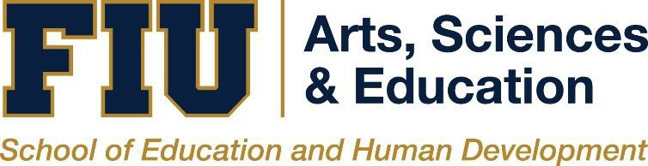

COUNSELOR EDUCATION PROGRAM
CACREP VITAL STATISTICS & ANNUAL PROGRAM REPORT 2021-2022

The purpose of this annual report is to inform students, the public, and community stakeholders about student enrollment, student success, key findings, decisions, and modifications of the program in line with our program mission statement and objectives. The information below is based upon the 2021-2022 academic year, as required by the Council on Accreditation for Counseling & Related Educational Programs (CACREP).

FIU’s Counselor Education program is comprised of three CACREP accredited tracks:
- Rehabilitation Counseling (Track coordinator: Dr. Valerie Dixon)
- School Counseling (Dr. Zachary Pietrantoni)
- Clinical Mental Health Counseling (Track coordinator: Dr. Christina McGrath Fair)

Other administrative/service appointments include:
- Program Director, Dr. Valerie Dixon
- CACREP Liaison, Dr. Valerie Dixon
- Chi Sigma Iota (Delta Iota) Chapter Faculty Advisor, Dr. Christina McGrath Fair
- Clinical Coordinator, Dr. Alena Prikhidko
- SARCA Faculty Advisor, Dr. Valerie Dixon
- Continuing Education Coordinator, Dr. Christina McGrath Fair
- Comprehensive Exam Coordinator, Dr. Christina McGrath Fair

FACULTY DEMOGRAPHICS

During the 2021-2022 academic year, there has been some transition in the faculty. The core faculty during Fall 2021 were Drs. Isaac Burt, Valerie Dixon, Christina McGrath Fair (Visiting Clinical Assistant Professor), Alena Prikhidko and Michelle Bradham-Cousar. Dr. Burt transferred to another university. Dr. Tameeka Hunter was hired as an Assistant Professor for the Rehabilitation and Clinical Mental Health Counseling (CMHC) tracks. Dr. Zachary Pietrantoni was hired as an Assistant Professor for the School Counseling (SC) track. The Fall 2022 semester faculty consisted of Drs. Dixon, Prikhidko, McGrath Fair, Bradham-Cousar, Hunter and Pietrantoni. Core faculty members include tenure-track/earning and clinical faculty lines. Each semester, adjunct faculty members serve the course needs of our students.

CORE FACULTY | Male | Female
African American/Black | 1 | 3
American Indian/Native Alaskan | 0 | 0
Asian American | 0 | 0
Caucasian/White | 1 | 2
Hispanic/Latino/Spanish American | 0 | 0
Native Hawaiian/Pacific Islander | 0 | 0
Multi-Racial | 0 | 0
Other/Undisclosed | 0 | 0

PROGRAM DEMOGRAPHICS

For this academic year, beginning Fall 2022 we received 175 applications to our CACREP-accredited Master’s program in Counselor Education. Students enroll in a full-time cohort model, which ensures timely graduation in 2.5 to 3 years.

STUDENTS | Male | Female
African American/Black | 0 | 16
American Indian/Native Alaskan | 0 | 0
Asian American | 0 | 0
Caucasian/White | 4 | 9
Hispanic/Latino/Spanish American | 7 | 46
Native Hawaiian/Pacific Islander | 0 | 0
Multi-Racial | 0 | 10
Other/Undisclosed | 0 | 1

Clinical Mental Health Counseling Track (60 semester credits)
Our mission is to prepare competent clinical mental health counselors to significantly impact diverse individuals in a variety of settings (e.g., hospital, agencies, private practice). Our program trains counselors to meet the challenges involved in working in a multiethnic, multicultural, and urban environment. The second part of our mission is to provide both educational experiences that emphasize multiculturalism in practice and theory as well as opportunities for professional and personal growth. Finally, it is our intent to produce ethical and responsible clinical mental health counselors who function to help others achieve positive personal change.

Currently, we have 58 students enrolled in the CMHC track. In the past year, we have had a total of 14 graduates. The CPCE is a graduation requirement for all CMHC students. Currently, students are provided authorization to take the exam once they are registered for practicum courses. The updated testing administration process includes students registering with CCE: Go to the CPCE registration link and fill out the required information (https://www.cce@global.org/Registration/CPCE_APB_Welcome), complete this registration at least 7 business days (not calendar) before testing to allow sufficient processing time. Once students complete the registration, they will receive an “Authorization to Test” email from Pearson within 7 business days. Students can test up to 3 times within the 6-month eligibility period if their eligibility will not expire before the test date. Eligibility period extensions can be granted by the exit exam coordinator on a case-by-case basis.

The results of these three administrations for 2021-2022 are:

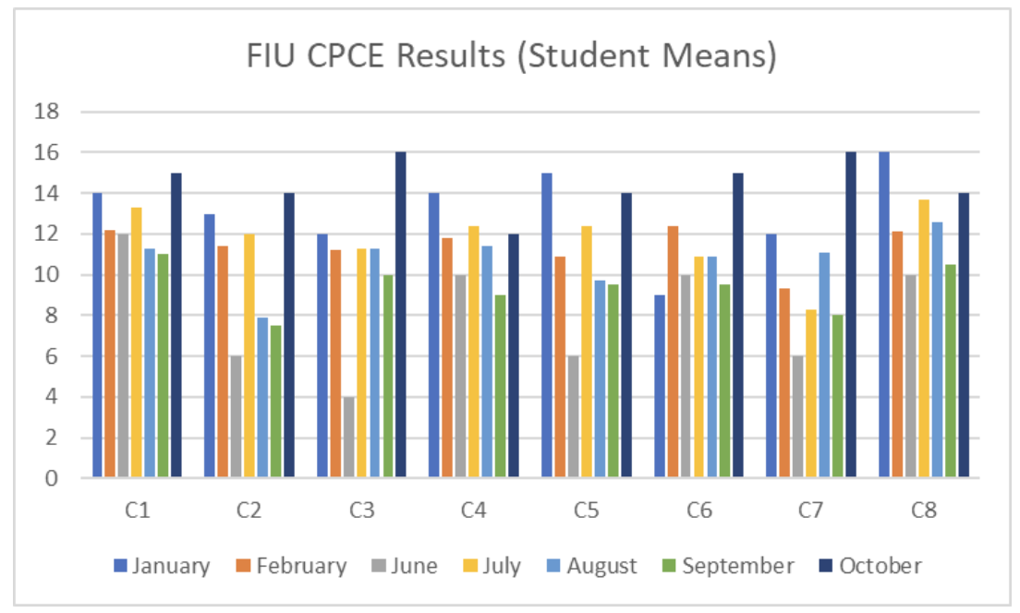

The passing rate for the CPCE is 100%. The job placement rate for Clinical Mental Health Counseling graduates is 90%.

Rehabilitation Counseling Track (RC) (60 semester credits)
Our mission is to prepare competent rehabilitation counselors to fulfill the national critical shortage of diverse and trained professionals who can provide vocational and rehabilitation counseling and services to individuals with physical and mental disabilities in a variety of settings (e.g., vocational rehabilitation agencies, private and forensic vocational rehabilitation services, rehabilitation centers, veteran hospitals, treatment centers, assisted living facilities). Secondly, to provide educational experiences that emphasize multiculturalism in practice and theory as well as opportunities for professional and personal growth. Thirdly, to produce ethical and responsible rehabilitation counselors who assist clients with physical, intellectual, and emotional disabilities reach their vocational and independent goals.

Currently, we have 17 students enrolled in the RC track. In the past year, we have had a total of 2 graduates in 2021-2022 academic year. The CRC is a graduation requirement for all RC students. Thus, the passing rate is 100%. The job placement rate for Rehabilitation Counseling graduates is 100%.

School Counseling Track (57 semester credits)

Our mission is to prepare competent professional school counselors to significantly impact diverse individuals in a variety of settings (e.g., K-12) through the implementation of a data-driven comprehensive school counseling program. Our program trains counselors to meet the challenges involved in working in a multiethnic, multicultural, and urban school environment. The second part of our mission is to provide both educational experiences that emphasize multiculturalism in practice and theory as well as opportunities for professional and personal growth. Finally, it is our intent to produce ethical and responsible school counselors who facilitate learning, development, and achieve positive change for students within urban, diverse school settings.

Currently, we have 19 students in enrolled in the SC track. In the past year, we have had a total of 10 graduates during the 2021-2022 academic year. Successfully passing the following Florida Teacher Certification Exams (FTCE) exams: General Education exam, Professional Education exam, and the Subject Area Exam in Guidance and Counseling, is a graduation requirement of all SC students: Thus, the passing rate is 100%. The job placement rate for School Counseling graduates is 100%.

MAJOR PROGRAM ACTIVITIES

The program is using online system Tevera to assess student data informing the program development. All new student files are maintained electronically. All students use Tevera during their practicum and internship courses/experiences.

The program admissions occur once per year in the Fall for the CMHC track and twice per year in the Fall and Spring for SC and RC tracks. The program continues to use cohort model, implemented in 2018. Students enroll in 3 courses per semester for fall and spring semesters, and a minimum of 2 courses for summer terms. The faculty is constantly working on adding new site placements for the Field Experiences and revising the current list of placements, so that we can better ensure quality experiences and appropriate supervision. Additionally, faculty ensures that all supervisors have received appropriate training or possess supervisory credentialing by the state of Florida.

Each fall semester, all faculty convene to review student dispositions and academic progress of each student in the CMHC track; while each spring semester, faculty reviews all students enrolled in the RC and SC tracks. The counselor education student dispositions are listed in the table below.

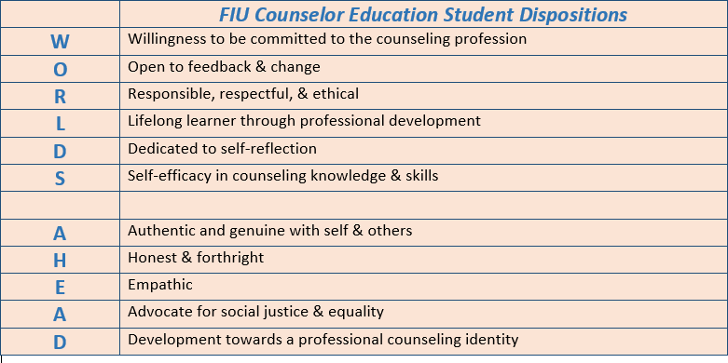

In sum, we are excited to report a total of 26 graduates during this academic year, with 93 currently enrolled, across all three specializations. Moreover, among the three tracks, our students have provided more than 26,000 hours of counseling service to the community.

Faculty Achievements

Dr. Isaac Burt

Publications

Meade, N.A., Branco, S., Burt, I., White, R., Hanks, A. (In press). Cultural appropriation, appreciation, and adaption: A rejoinder to Greenleaf. Journal of Counseling and Development.

Burt, I. & Gonzalez, T. (2021). Flow state as an existential tool to increase optimal experience and life enjoyment. Journal of Humanistic Counseling, 60, 197-214. https://doi.org/10.1002/johc.12165

Burt, I., & Jenkins, K. (2021). Challenging cultural and systemic institutional norms that impede effective therapeutic relationships. Journal of Multicultural Counseling and Development, 49, 196-198. https://doi.org/10.1002/jmcd.12224

Burt, I., Pham, A., &. Hyun, J. (2021). Reexamining Asian-American masculinity and the model minority myth through a school-based counseling group. Professional School Counseling, 25 (Ic), 1-11.https://doi.org/10.1177/2156759X211040032

Pham, A.V., Goforth, A.N., Aguilar, L.N., Burt, I., Bastian, R., & Diaków, D. (2021). Dismantling systemic inequities in school psychology: Cultural humility as a foundational approach to social justice. School Psychology Review. Advance online publication. https://doi.org/10.1080/2372966X.2021.1941245

Burt, I. (2020). I get money: A therapeutic financial literacy group for Black teenagers. The Journal for Specialists in Group Work, 45(2), 165-181. https://doi.org/10.1080/01933922.2020.1740845

Book Chapter

Burt, I., Yellowhair, J., & Ivey, A. (2021). Clinical skills from a multicultural perspective: Counseling Native/Indigenous populations. In S.K. Butler & J. Filmore (Eds.), Introduction into 21st century counseling. San Diego, CA. Cognella.

Non-Peer Reviewed Publications

White, R., Hanks, A., Branco, S., Meade, N., & Burt, I. (2020). A collective voice: Indigenous resilience and a call for advocacy. Counseling Today. Retrieved from: https://ct.counseling.org/2020/02/a-collective-voice-indigenous-resilience-and-a-call-for-advocacy/

Presentations at Conferences

Hines, E., Moore, J.L., Butler, S.K., Shillingford-Butler, A., Smith, V., Appling, B., Robinson, S., Burt, I., & Challenger, C. (2021, October). Males of color and school counseling: Major considerations and best practices. Presentation presented at the Association for Counselor Education and Supervision Conference in Atlanta, GA.

Burt, I. & Gonzalez, T. (2021, April). Using the neuroscience idea of flow state with multiculturalism to increase wellness. Presentation presented at the American Counseling Association Conference in Orlando, FL.

Mitchell, M., Burt, I., Martinez, M., Band, M. (2020, March). Cross-cultural mentoring: A multicultural model for inclusion in the 21st Century. Presentation accepted at the American Counseling Association Conference in San Diego, CA. (Conference cancelled due to COVID-19).

Grants

Burt, I., Jefferson, J., Reid, M., Caraballo, A., & Fletcher, T., (2020). Strong and powerful: Unity and collaboration between HBCUs and HSIs. Department of Counseling, Recreation, and School Psychology (CRSP) Collaborative Projects on Equity, Diversity, & Social Justice seed grant (Collaboration between the departments of CRSP, Engineering, Psychology, and Public Policy & Administration). Principal Investigator. 2020-2021. $8,000, awarded.

Burt, I., Russell, V.D., & Jones, G. (2020). Making it rain: A therapeutic financial literacy group for Black/African American teenagers. Department of Counseling, Recreation, and School Psychology (CRSP) Collaborative Projects on Equity, Diversity, & Social Justice seed grant. Principal Investigator. 2020-2021. $4,000, awarded.

Funded Fellowships

Burt, I. (2019). ADVANCE Faculty Fellowship. (2019-2020).

National Professional Service

2021-Present Co-chair for ACA 2021-2022 Black Male Experience Task Force Committee

2020-Present Associate Editor, Journal of Multicultural Counseling and Development

2018-2021 Editorial board member, Journal of Multicultural Counseling and Development (Second Term)

2018-2021 Editorial board member, Journal for Specialists in Group Work

2019-Present Advisory Board member for ACA-endorsed Council of State Governments (CSG) to develop an occupational licensure compact (National licensure)

2014-2020 Vice President for Native American Concerns Group for the Association for Multicultural Counseling and Development (AMCD)

Dr. Valerie Dixon

Funded Research:

Dixon, V. E. (PI). (2020-2025). Training “A.B.L.E” Rehabilitation Counselors at Florida International University. Department of Education RSA Long-term training grant.
Funded amount: 900,000.00
Dixon, V. E. (PI). (2019-2024). Training “Beyond Possible” Rehabilitation Counselors at Florida International University. Department of Education RSA Long-term training grant.
Funded amount: 900,000.00

National Invited Presentations:

Dixon, V. E. (2022). ARCA: Future initiatives and professional outlook perspectives. 2022
Association of Veterans Affairs Vocational Rehabilitation Professionals. Virtual.
National Conference Presentations:

Bradham-Cousar, M., Dixon, V.E., and Moore, L. (2022). Students with Special Needs and School Counselor Collaboration. 2022 American Counseling Association (ACA) Virtual Conference.
Dunlap, P., & Dixon (Russell), V.E.D. (2021). Modern Slavery: The intersection of disability and human trafficking. 2020 American Counseling Association (ACA) Conference and Expo. Virtual.

Leadership and Service:

President- American Rehabilitation Counseling Association 2022-23
President-Elect- American Rehabilitation Counseling Association 2021-22
Director, Organization, Administration and Management Council, American Rehabilitation Counseling Association 2016-2021
Program Director- Counselor Education. Florida International University 2021-present
Rehabilitation Counseling Track Coordinator- Counselor Education. Florida International University 2011-present
Faculty Advisor- Student American Counseling Association (SARCA). Florida International University. 2018-present

Dr. Christina McGrath Fair

Invited Presentations

Daylor, S., Wescott, J., & McGrath Fair, C. (2022). Advocacy Against Anti-LGBTGEQIAP+ Legislation: What Counseling Professionals Can Do, Society for Sexual, Affectional, Intersex, and Gender Expansive Identities Webinar Series, Virtual.

McGrath Fair, C. (2021). Florida Boundaries & Ethics 3-hour CE, Presentation for FCA Convention Pre-convention, Virtual.

State Presentations

McGrath Fair, C., Machado, M., & Shure, L. (2021). Mentor Relationships in Social Justice
Counseling, Presentation at the Florida Counseling Association Convention, Virtual.

Awards

2021 Florida Counseling Association Member of the Year

Leadership & Service

Chi Sigma Iota – Delta Iota Chapter Faculty Advisor
Counselors for Social Justice – Co-chair Mentorship Committee
Florida Counseling Association – SAIGE-FL Past President, FCA Foundation Board Member, FCA Convention Coordinator
Association of Counseling Sexology & Sexual Wellness – Chair Social Justice & Advocacy Committee
Society for Sexual, Affectional, Intersex, & Gender Expansive Identities – Conference Committee Member

Dr. Alena Prikhidko

Publications

Swank, J. M., Weaver, J. L., & Prikhidko, A. (2021). Children and Adolescents’ Lived Experiences During the COVID-19 Pandemic. The Family Journal. https://doi.org/10.1177/10664807211052303

International Investigation of Parental Burnout (IIPB) Consortium. (2021). Parental Burnout Around the Globe: A 40-country study. Affective Science, 2(1), 58-79

Kenny, M., Prikhidko, A. (2021). Mothers’ Attitudes Toward Child Sexual Abuse Prevention in Schools. Journal of Child and Adolescent Trauma, https://doi.org/10.1007/s40653-021-00361-1

Long, H., Prikhidko, A., Bendeck, A.C., Yumusak, S. (2021). Measurement invariance of Intensive Parenting Attitudes questionnaire across gender and race. Journal of Family Psychology. Advance online publication. https://doi.org/10.1037/fam0000889

Prikhidko, A., & Kenny, M. (2021). Examination of parents’ attitude toward and efforts to discuss child sexual abuse prevention with their children. Child and Youth Services Review, 121, 105810. https://doi.org/10.1016/j.childyouth.2020.105810

Prikhidko, A., Long, H., & Wheaton, M. G. (2020). The effect of concerns about COVID-19 on anxiety, stress, parental burnout, and emotion regulation: The role of susceptibility to digital emotion contagion. Frontiers in Public Health, 8, 894. https://doi.org/10.3389/fpubh.2020.567250

Swank, J., Jo, L., & Prikhidko, A. (2020). Children and adolescents’ lived experiences during COVID-19. Revised and Resubmitted. Journal of Children and Adolescents.

Prikhidko, A., & Swank, J. (2020). Exhausted parents experience of anger: The relationship between anger and burnout. The Family Journal, 28(3), 283-289. https://doi.org/10.1177/1066480720933543

Wheaton, M., & Prikhidko, A. (2020). Is fear of COVID-19 contagious? The effects of emotion contagion and social media use on anxiety in response to the coronavirus pandemic. Frontiers in Psychology, 11. https://doi.org/10.3389/fpsyg.2020.567379

Jacob, C., & Prikhidko, A. (2020). Exploring emotion regulation in counselors’ management of attraction to clients. Journal of Creativity in Mental Health, 1-14. Advance Online Publication. https://doi.org/10.1080/15401383.2020.1856015

Prikhidko. A., Su, Y.-W., Housckeshnet, A., & Swank, J.(2020). Emotion regulation for counselors-in-training: A Grounded Theory. Counselor Education and Supervision, 59(2), 96-111. https://doi.org/10.1002/ceas.121169

Book Chapter

Prikhidko, A. (2020). Domestic Violence in Russia: Marriage and Gamily Counseling Approach. International Handbook on Marriage and Family Therapy. Guilford Press

Conference Presentations

Prikhidko, A., Long, H., Wheaton, M. (2021). The Effect of Covid-19 on Parental Burnout: Digital Emotion Contagion. International Conference on Parental Burnout

Dr. Michelle Bradham-Cousar

Books and Book Chapters

Bradham-Cousar, M., Blanco, S., Machuca, R., & Galvez, D. (accepted, 2022). Latino/Hispanic Men, Cultural Identity, and Career Development. In Latino Male Identity: A Mental Health Crisis of Otherness, Indifference, and Exclusion. Information New Age Publishing Group.

Refereed Journal Articles

Bradham-Cousar, M. (in progress, 2023). Accessibility in Communities for People with Disabilities in STEM. Journal of Accessibility and Design for all.

Bradham-Cousar, M., (in progress, 2023). Equity? Black Men Health Disparity in Mental Health. Journal of Multicultural Development.

Johnson Austin, S., Gabbidon, K., Bradham-Cousar, M., &Moore, L.L. (in progress, 2022). Equity in STEM: Supporting Marginalized Women in Academia. The International Journal of STEM Education.

Bradham-Cousar, M., McCullough, K., & Nicholas, D. (in progress, 2022). Vocational Evaluation and Spirituality. Counseling and Values.

Non-Refereed

Resolution No. F3 (2021). 2021-12-09 Council Agenda.pdf (revize.com) Sears, R., Reichgelt, J., McHale, J., Gallardo, G., Reese, G., Dutton, T. Akiwumi, F., Thompson-Dorsey, D., Bradham-Cousar, M., Edmond, J., Blackshear, J. Structural Racism Study: Building Bridges and Supporting Racial Equity. p.173-384

Presentation

Bradham-Cousar, M., Guyton, C., McCullough, K, & Rodriguez, G. (2022). Faculty Alliance with the CACREP Counselor Education Curriculum, Counselor Education and Competencies of Disability. American Counseling Association, Toronto, Canada.

Bradham-Cousar, M., Blanco, S., Machuca, R., & Galvez, D., (2023) Latino/Hispanic Men, Cultural Identity, and Career Development. American Counseling Association, Toronto, Canada.

Johnson Austin, S., Bradham-Cousar, M. & Gabbidon, K. (2023). Intersectionality: Professional identity formation and the success of women of color in higher education STEM disciplines. Collaborative Network for Engineering and Computing Diversity. New Orleans, LA.

Bradham-Cousar, M. & Guyton, C., (2022). Integrating Disability Competencies into CACREP Counselor Training Programs: Considerations for Best Practice. Florida Counseling Association, Orlando, Fl.

Bradham-Cousar, M., Dixon, V., & Moore, L. (2022). Students with Special Needs and School Counselor Collaboration. American Counseling Association, Alexandria, VA

Bradham-Cousar, M. (2022). Military Veterans with TBI and Mental Health. Texas Tech University Health Sciences Center. Veteran Mental Health Symposium, Lubbock, Texas.

Johnson Austin, S., Bradham-Cousar, M., Moore, L., & Gabbidon, K. (2022). Equity in STEM: Supporting SISTaS’ persistence in the academy via C10 framework during a pandemic. Women in Engineering ProActive Network (WEPAN), Washington, DC.

Bradham-Cousar, M. (2022). Rehabilitation Engineering and Traumatic Brain Injury. Equity in STEM (Science, Technology, Engineering and Math). Florida AGEP Research Symposium. Tampa, Florida.

Bradham-Cousar, M. & Smith, S. (2022). Non-Profit Organizational Risk Management for Sustainability. American Counseling Association. Alexandria, VA.

Bradham-Cousar, M., Gabbidon, K., & Johnson Austin, S., Moore, L. (2022). 2.0: Supporting SistsaS’ Presentence in the Academe via C10. USF Diversity & Inclusion Conference, Tampa, Florida.

Bradham-Cousar, M. & Smith, S. (2022). Risk Management for State 2 State development. American Counseling Association. Alexandria, VA.

Moore, L., Bradham-Cousar, M., Gabbidon, K., & Johnson Austin, S. (2021). Supporting SistsaS’ Presentence in the Academe via C10. Education for Justice: The 2nd Annual Anchin Center Conference, Tampa, Florida.

Bradham-Cousar, M. (2021). Careers in Rehabilitation Counseling. Albany State University, Albany, GA.

Grants Funded

2022 APA ENG ASEE ($5000) P.I. Dr. Johnson-Austin
2022 Bethune Cookman ($3000) P.I. Dr. Bradham-Cousar
2021 Structural Racism for St. Petersburg ($50,000) Dr. P.I. Dr. Sears

Grants Pending Award

2023 National Science Foundation (NSF) P.I. Dr. Bradham-Cousar
2023 National Institute of Health (NIH) P. I. Dr. Bradham-Cousar

Grants not Funded

2022 Humanities Area Studies Research (HAS) P.I. Dr. Bradham-Cousar
2022 ARC Network (P.I.) Dr. Bradham-Cousar
2021 CRSP Collaborative Projects on Equity (P.I.) Dr. Bradham-Cousar

Journal Reviewer

2022 Adultspan Journal

Dr. Tameeka Hunter

Book Chapter

Kucharczyk, S., Frazier, K., Hunter, T., Perryman, K., Thomas, J., Speight, R. & Bengston, E. (in press). Teaming for transition: A model for interdisciplinary, collaborative preparation of secondary education professionals. In D. D. Slanda & L. Pike (Eds.). Handbook of Research on Interdisciplinary Preparation for Equitable Special Education. IGI Global. https://www.igi-global.com/book/_/301606

Peer-Reviewed Conference Presentation

Hunter, T., Perryman, K., & Thomas, H. (Accepted, 2023, April 1). Using Creative Therapies with Clients with Disabilities [Clinician Education Session]. ACA 2023 Conference & Expo, Ontario, Canada.

Dr. Zachary Pietrantoni

Papers

Chitiyo, A., Chitiyo, J., & Pietrantoni, Z. (2022) Rights-based education programming: A complementary approach for addressing poverty, education inequality, and development in Zimbabwe. Journal of International Education and Practice, 5(1). doi: https://doi.org/10.30564/jiep.v5i1.4770

Book

Chitiyo, J., & Pietrantoni, Z. (In press). Social justice and culturally affirming education in the K-12 settings. Hershey, PA: IGI Publishing
Chapters

Chand, R., Alasa, V., Chitiyo, J., & Pietrantoni, Z. (2022). Preparation of pre-service teachers: Assessment of Generation Z students. In J. Keengwe (Ed.), Handbook on Digital-Based Assessment and Innovative Practices in Education. Hershey, PA: IGI Publishing
McDaniel, S., Pietrantoni, Z., & Chen, S. (2022). Supporting students with disabilities in transition: Collaboration between school counselors and special educators. In L. Meda & J. Chitiyo, (Eds.), Inclusive Pedagogical Practices Amidst a Global Pandemic: Issues and Perspectives Around the Globe. New York: Springer.
Alasa, V., Chitiyo, J., & Pietrantoni, Z. (2022). Entrepreneurship education: Equalizing opportunities for women with disabilities. In J. Keengwe, (Ed.), Handbook of Research on Promoting Global Citizenship Education. Hershey, PA: IGI Publishing.

Presentations

Pietrantoni, Z., Chitiyo, J., Chitiyo, A., *Pena, J. Q., & *Fernandez, K. (2023, March). Training outcomes: Survey results about identifying and reporting child maltreatment. Poster accepted at the annual conference of the American Counseling Association. Toronto, ON, Canada
Shi, Y., Pietrantoni, Z., & See, M. (2022, December). International mental health education, services, and research: Working across cultural boundaries with humility, creativity, and perseverance. Keynote presented at the annual international conference of the National Board of Certified Counselors Foundation. Online
Pietrantoni, Z., Chitiyo, J., & Alasa, V. (2022, November). Educators’ attitudes, knowledge, and training experiences of youth maltreatment in Fiji. Education session presented at the annual international conference of the Oceania Comparative and International Education Society. Lautoka, Fiji
Pimentel, M., & Pietrantoni, Z. (2022, October). Supporting undocumented students in schools: Reflections of training strategies for counselors. Education session presented at the biennial conference of the Western Association of Counselor Education and Supervision. Portland, OR, USA
Chen, S., Pietrantoni, Z., See, M., & Shi, Y. (2022, October). Supporting East and Southeast Asian clients: A panel on culturally centered training and practices. Education session presented at the biennial conference of the Western Association of Counselor Education and Supervision. Portland, OR, USA

Professional Appointments

Professional appointments
Reviewer for the International Journal of Psychotherapy
Reviewer for Preventing School Failure: Alternative Education for Children and Youth
Treasurer for the Western Association of Counselor Education and Supervision
Budget and Finance Committee for the Association of Counselor Education and Supervision

As the only public, CACREP-accredited institution serving the greater Miami-Dade area, we are committed to promoting excellence in counseling and serving the academic and mental health needs in our community.

Sincerely,

Valerie E. Dixon, Ph. D, CRC, LMHC, NCC
Program Director, Counselor Education
Coordinator, Rehabilitation Counseling Program
Florida International University
College of Arts, Sciences and Education
School of Education and Human Development
11200 S.W. 8th Street, ZEB 238B
Miami, FL. 33199
305-348-3865(O)
305-348-1515(F)
vdixon@fiu.edu

CC: All Counselor Education Faculty
All Counselor Education Advisory Board Members Department Chair
CASE Dean Provost’s Office

