CASE
Panthersoft Scheduling
Quick Overview

Email: casesched@fiu.edu

Navigating to a Specific Class Section
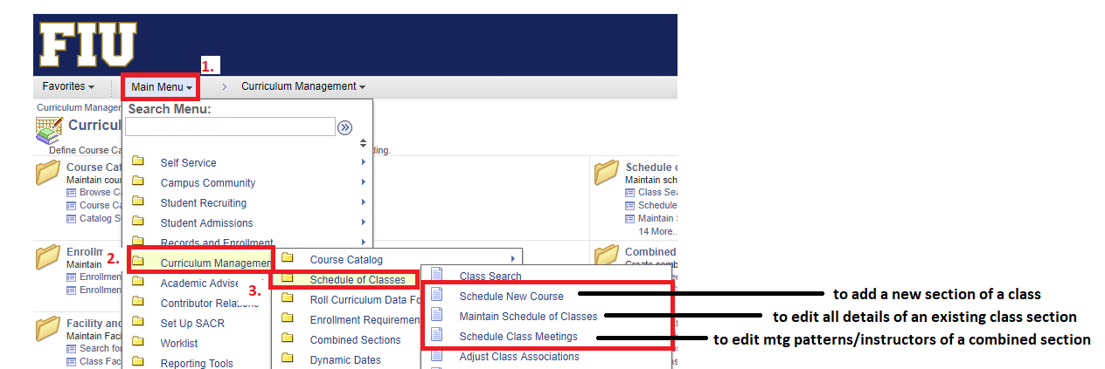

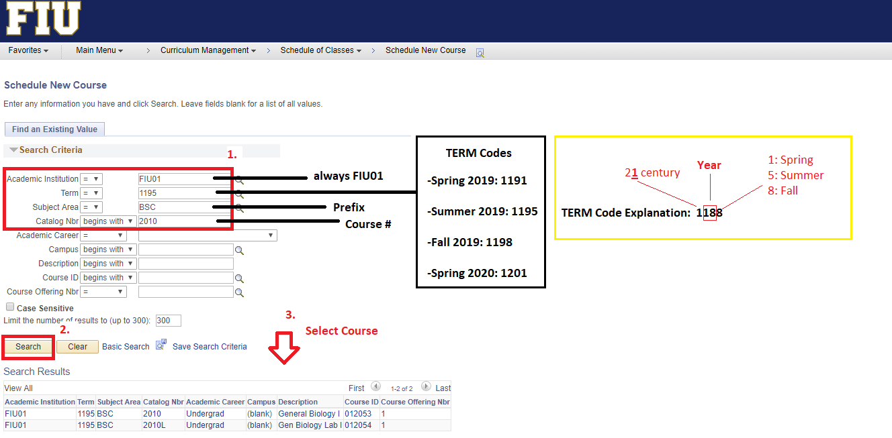

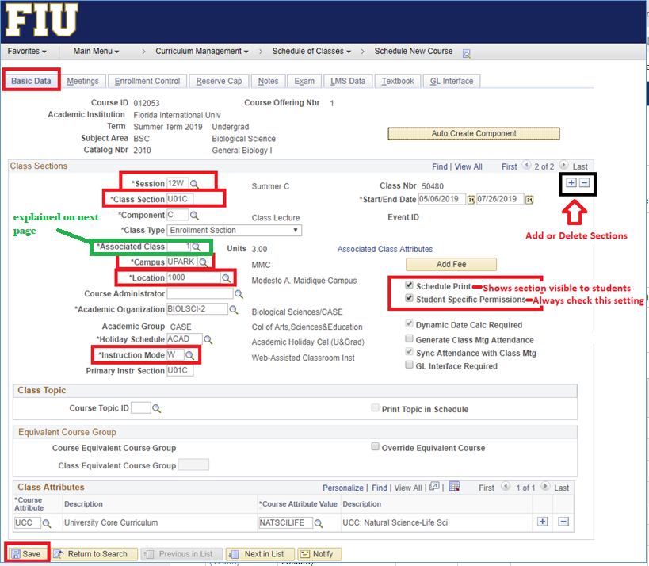
Basic Data Tab
- Session
- Section Number
- Associated Class Number
- Campus
- Location
- Instruction Mode
- Visibility of Section to Students
- Students Specific Permission Setting
- Add/delete sections
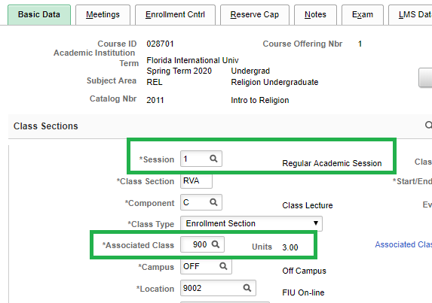
Sessions and Associated Class Numbers

- Session Codes and Description:
  - Session A: 7W1 (Fall/Spring A) and 6W1 (Summer A)
  - Session B: 7W2 (Fall/Spring B) and 6W2 (Summer B)
  - Session C: 1 (Regular) and 12W (Summer C)

Associated Class Numbers
- Online Classes

  - 900 – Fully Online Classes in Sessions C /Regular (e.g. 1, 12W)
    - Allows fully online students to enroll in the section

  - 400- Fully Online Classes in Sessions A (e.g. 7W1, 6W1)
    - Allows online students to enroll in sequential courses in the same semester

  - 420- Fully Online Classes in Sessions B (e.g. 7W2, 6W2)
    - Allows online & face to face students to enroll in sequential courses in the same semester
- On-Campus Classes

  - 1 – Face to Face Classes in Sessions C /Regular (e.g. 1, 12W)
    - Blocks fully online students from enrolling in the section

  - 300 – Face to Face Classes in Session A (e.g. 7W1, 6W1)
    - Allows face to face students to enroll in sequential courses in the same semester

  - 320 – Face to Face Classes in Session B (e.g. 7W2, 6W2)
    - Allows face to face students to enroll in sequential courses in the same semester
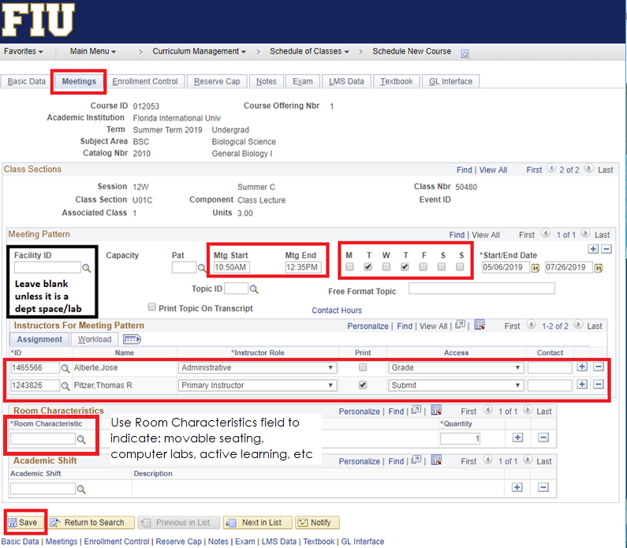
Meetings Tab
- Time
- Days
- Instructors
- Instructor Grading Access
- Room Characteristics
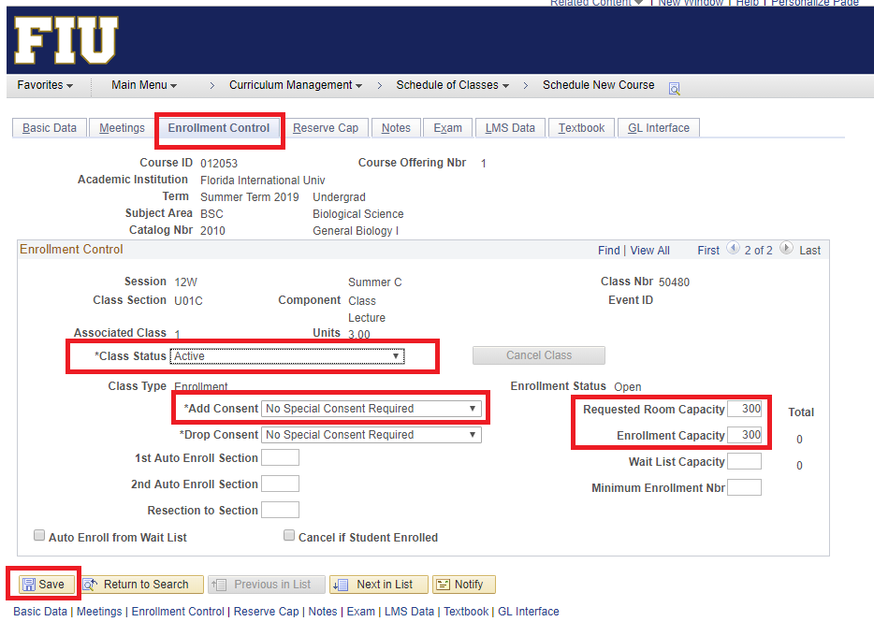
Enrollment Control Tab
- Class Status
- Consent to Add
- Requested Room Capacity
- Enrollment Capacity
Running the Schedule Query
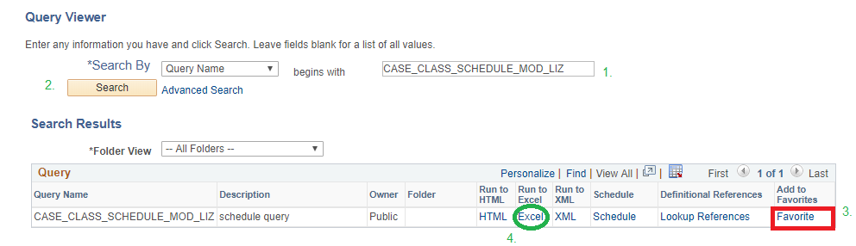
- Log into PantherSoft: Main Menu>Query Viewer
- Search Query Name: CASE_CLASS_SCHEDULE_MOD_LIZ
- Run to Excel

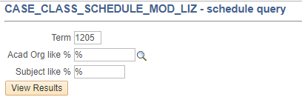
- Prompts:
  - TERM: 1205
  - Acad Org: %
  - Subject: %

New Combined Sections
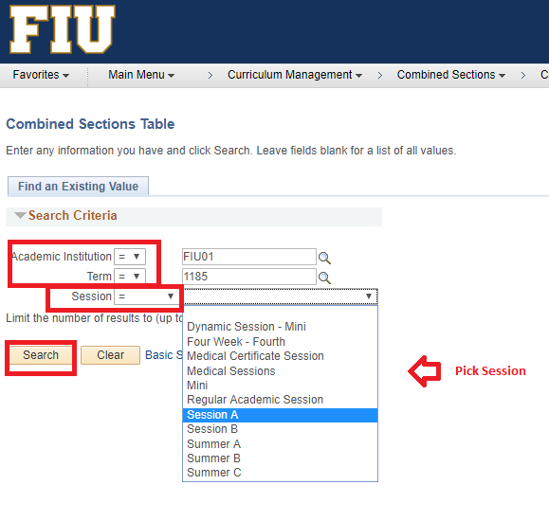
Create each individual class section through Maintain Schedule of Classes prior to combining them

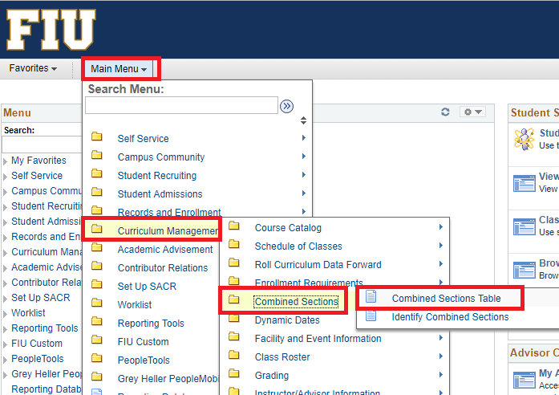

New Combined Sections (continued)
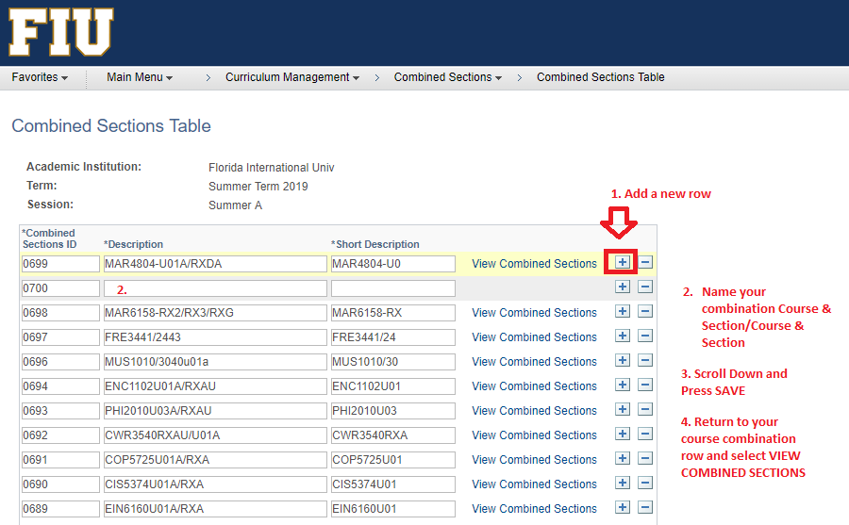

New Combined Sections (continued)
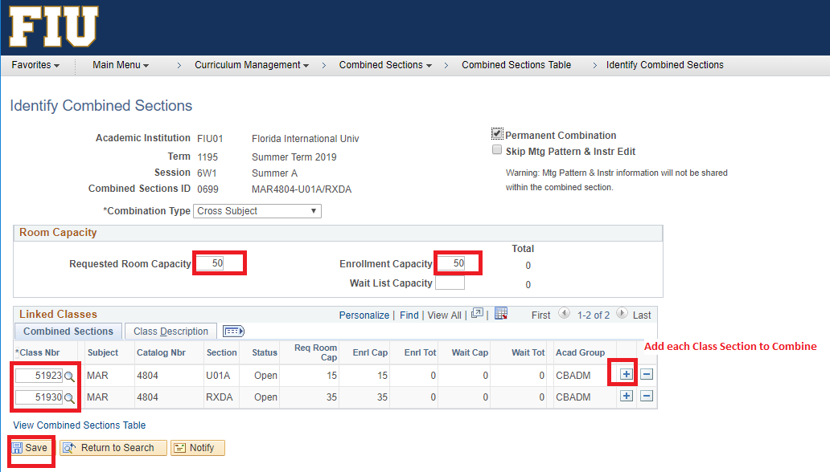
Note: If error occurs stating that sections have different mtg patterns/instructors, then return to one of the sections under Maintain Schedule of Classes and erase the mtg pattern, SAVE, then attempt to combine again.
Class Notes
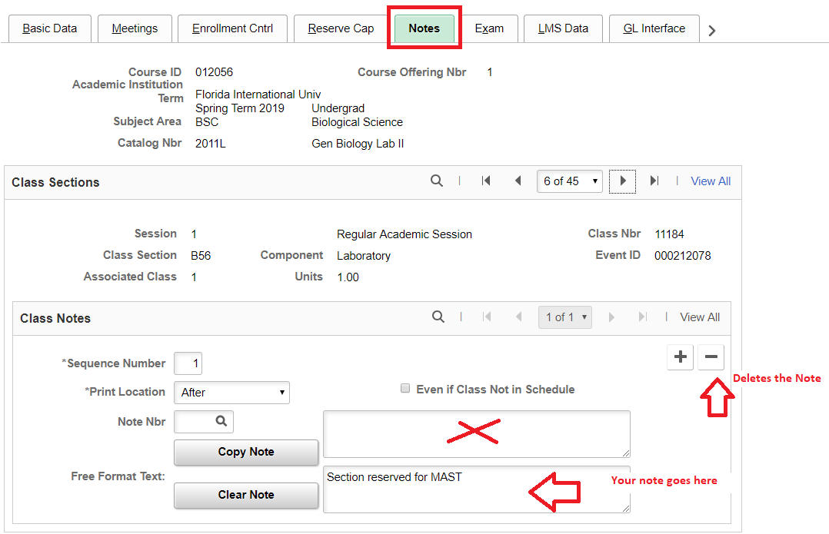

Tips for Scheduling Success

Check for 2nd mtg patterns as you key-in your schedule
  - Consolidate mtg patterns into one mtg pattern if multiple rooms were assigned last semester
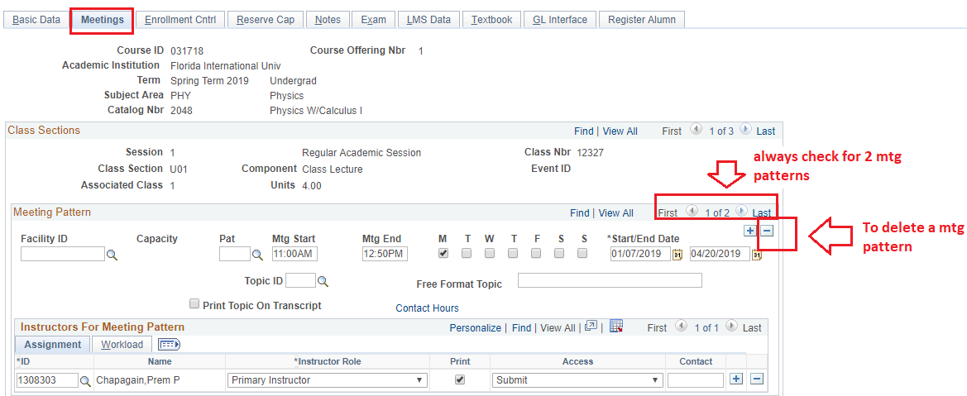
  - Delete duplicate mtg patterns

Assign lab and dept. spaces only to your classes before key-in ends
-For general assignment rooms, please leave facility id blank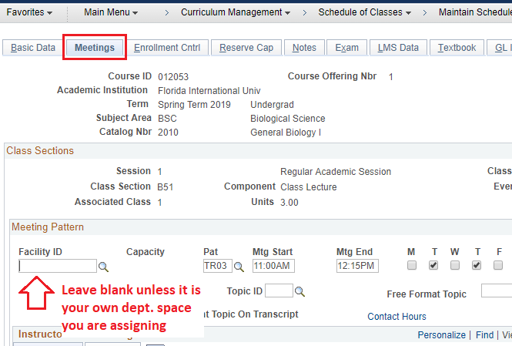

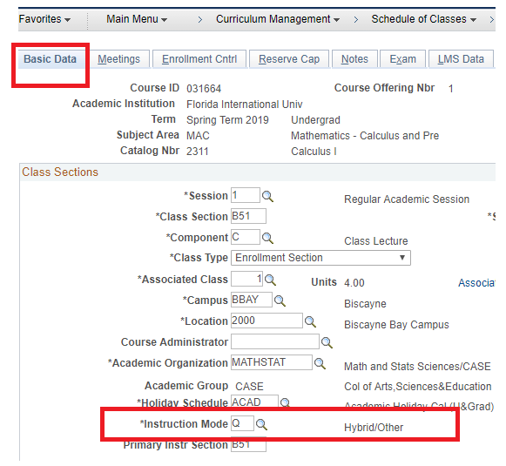
Instruction Mode: H: Hybrid/Certified vs. Q: Hybrid/Other

Effective 1185 and going forward

What changed?
In the past, all Hybrids were coded as “H”. Now a Hybrid Course is either:
H – Certified Hybrid or Q – non-certified Hybrid

How do you know who is a Certified Hybrid Instructor?
Click here for Certified Hybrid Instructor List
If you need access to list above, email olanalytics@fiu.edu

Certified Hybrid courses must schedule no more than half of their regular contact hours in the classroom. The other 50% of the contact hours are to be completed out-of-class/online.

See Certified Hybrid Contact Hours Sheet for guidelines.

Please direct any questions or concerns about how best to schedule certified hybrid courses that deviate from guidelines to Leanne Wells (lwells@fiu.edu) and/or Patty Delgado (pdelgado@fiu.edu)

DELETE (not cancel) class sections that will not be offered
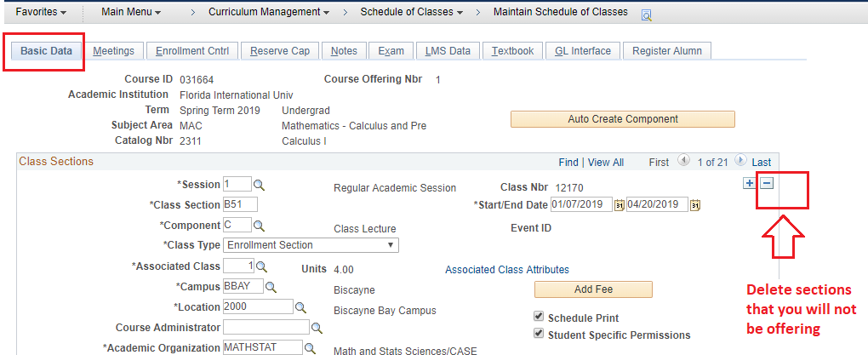

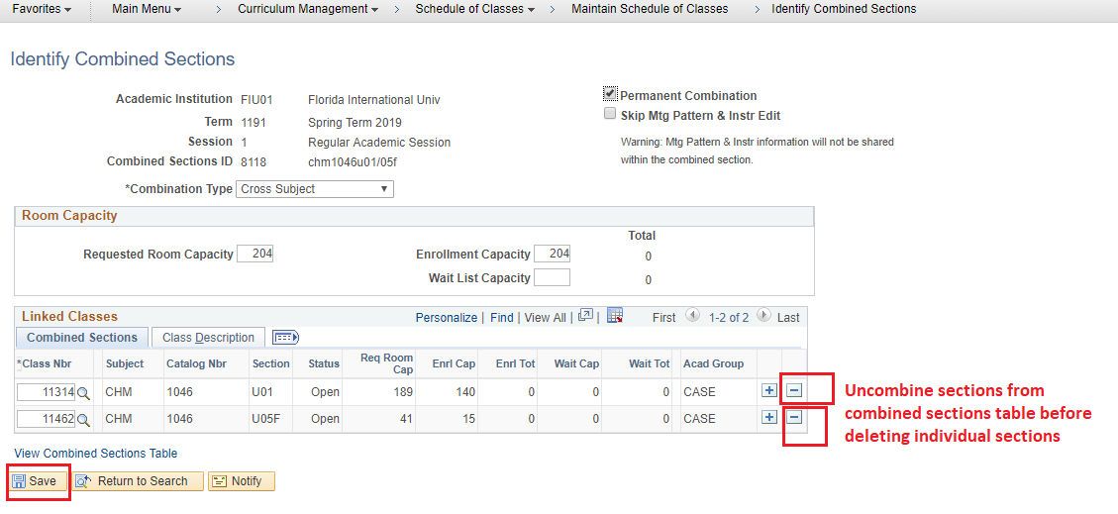
UNCOMBINE sections from the Combined Sections Table prior to Deleting

