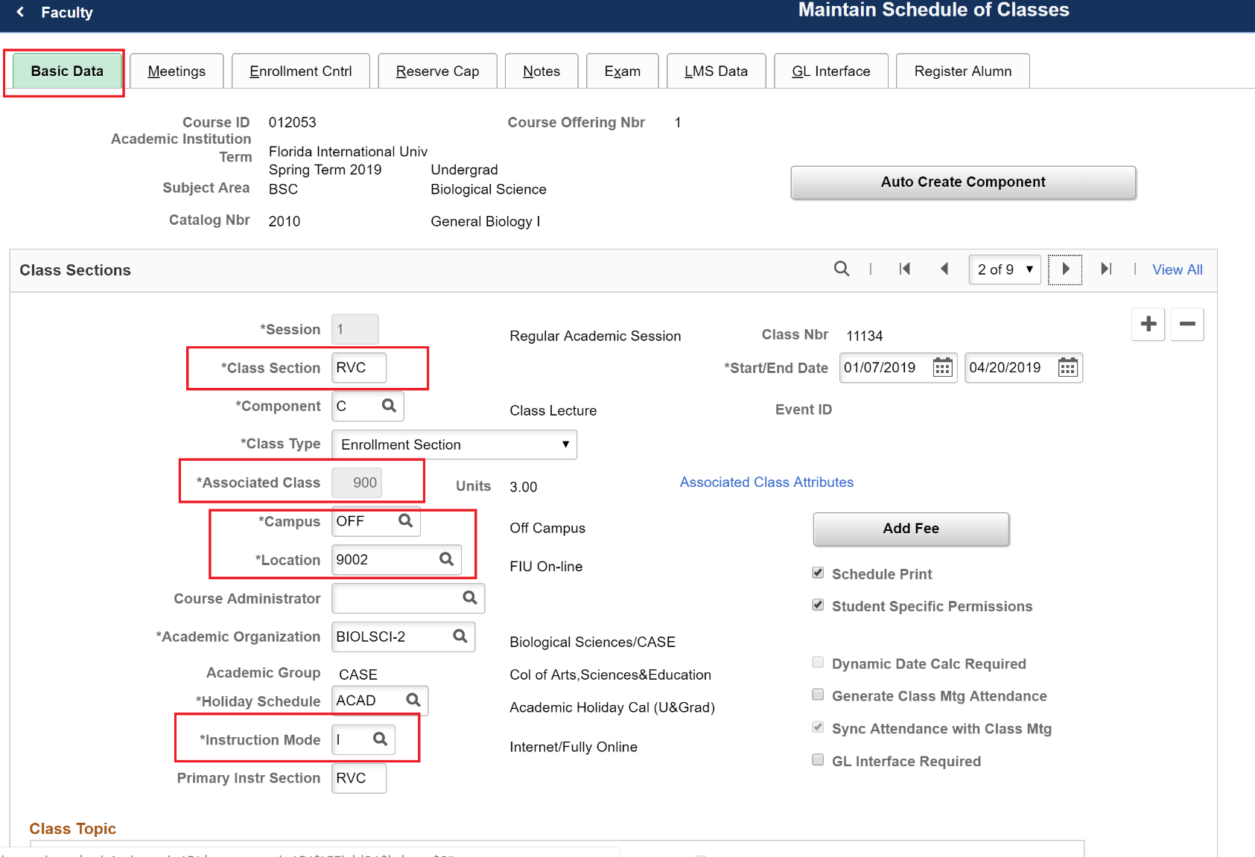
Class Section: Follow naming conventions below
- Regular Fall and Spring: RVC, RVD, RVE, RVF, etc.
- Summer A or Spring/Fall A: RVAA, RVDA, RVEA, RVFA
- Summer B or Spring/Fall B: RVBB, RVEB, RVFB, RVHB, etc.
- Summer C: RVCC, RVDC, RVFC, RVGC, etc.
---------------------------------------------------------
Associated Class Numbers for Online Classes
Regular/Summer C: 900
Spring/Fall A sessions: 400
Spring/Fall B sessions: 420
----------------------------------------------------------------
Campus: OFF
----------------------------------------------------------------
Location: 9002 (for regular online classes)
- Online Dual Enrollment - Location: 9006
- Market-Rate Online - Location: 9004
-------------------------------------------------
Instruction Mode: I
Note:
All other fields should still be modified accordingly (such as Session, Student Specific Permissions, Schedule Print).
I have only emphasized the fields that are particular to online course scheduling.
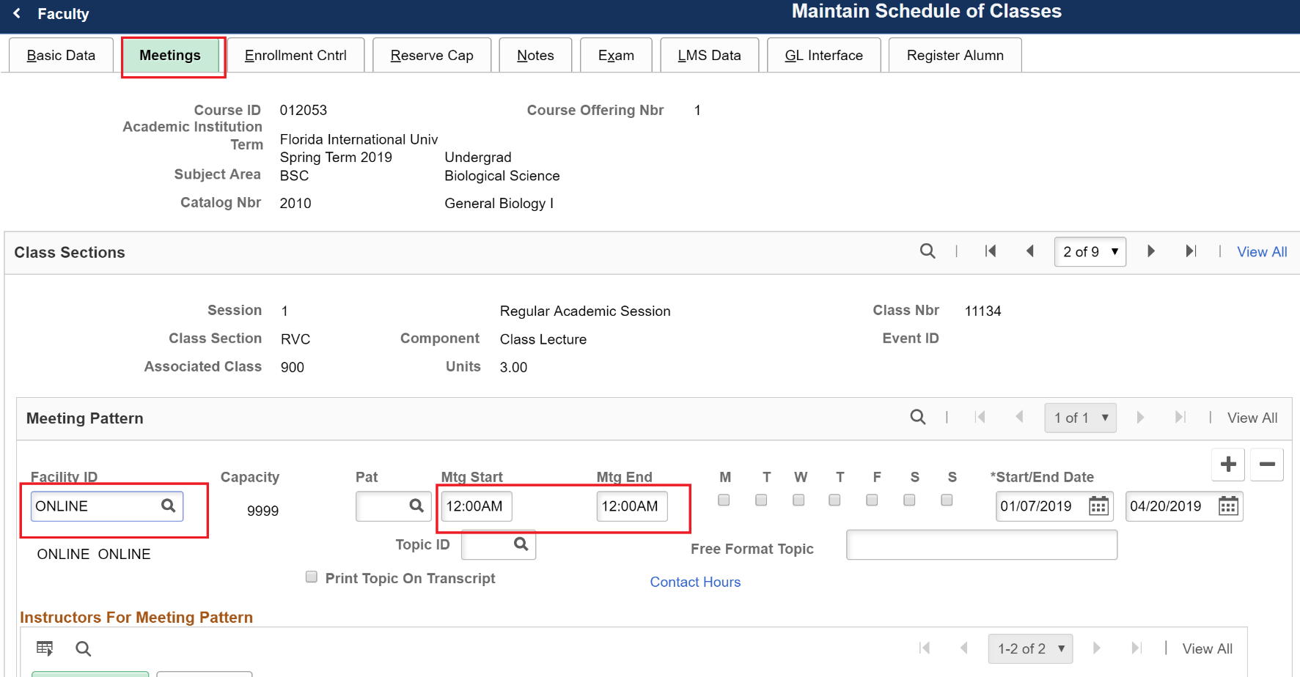
Facility ID: Please insert ONLINE in this field

Mtg Start and Mtg End:
12:00AM to 12:00AM

Online Class Fee Notes will be set up by FIU Online.
LMS Tab will also be set up by FIU Online.

