Running the Schedule Query
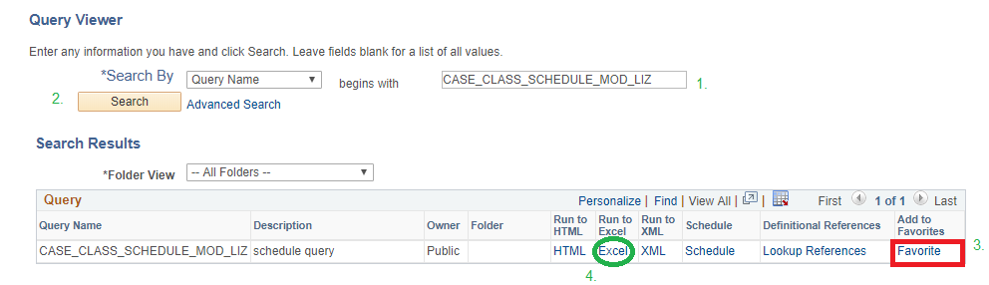
- Log into PantherSoft: Main Menu>Query Viewer
- Search Query Name: CASE_CLASS_SCHEDULE_MOD_LIZ
- Run to Excel

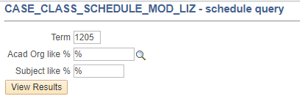
- Prompts:
  - TERM: 1205
  - Acad Org: %
  - Subject: %

In Microsoft Excel:
- Select the header row
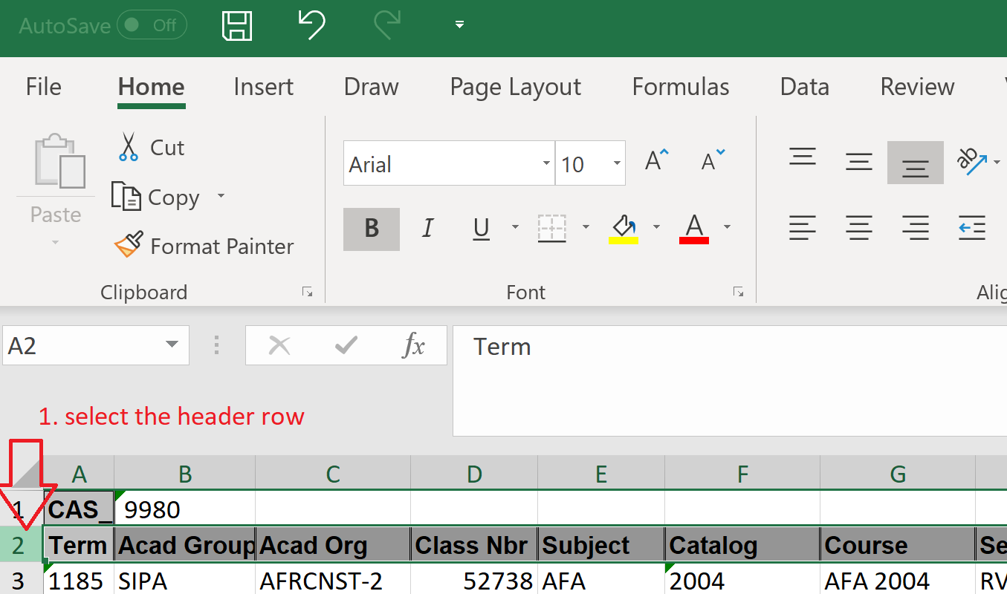
- Enable filter
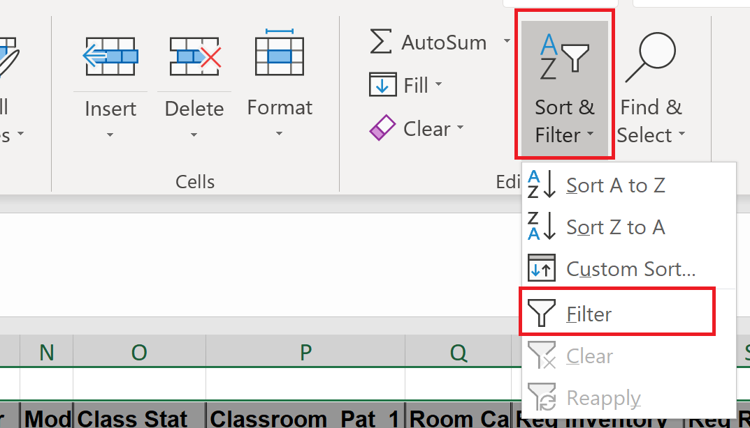
- In the Acad Org (Dept.) column, select your department
