Log into my.fiu.edu

Then, select Student Success Admin from the dropdown

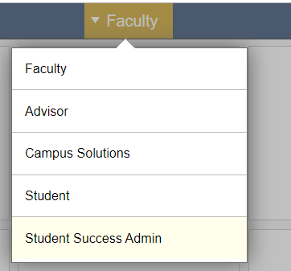

Select Dashboards
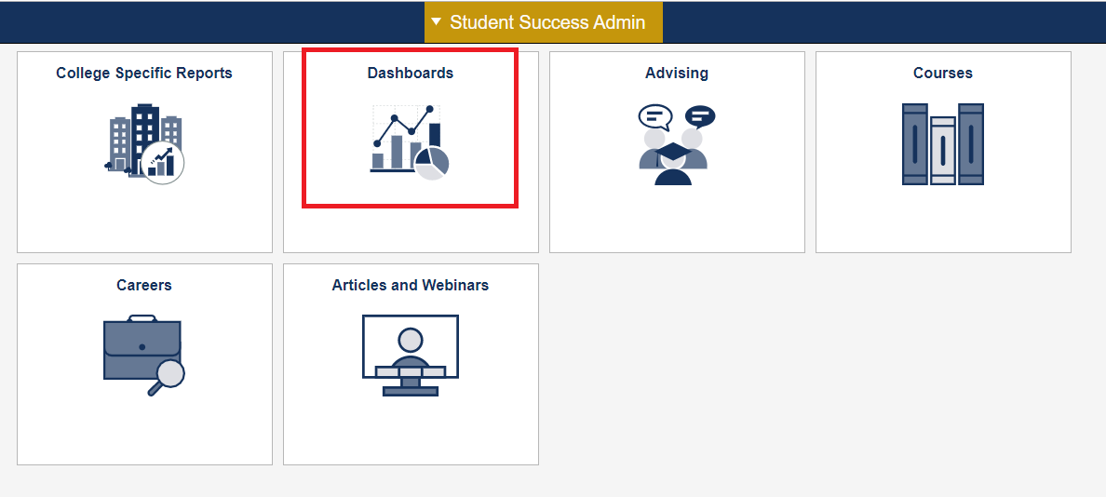

Select Business Intelligence (BI) from the left hand panel
Then, follow instructions for new users
Once you have access, you can navigate to the course schedule dashboard (as shown below)

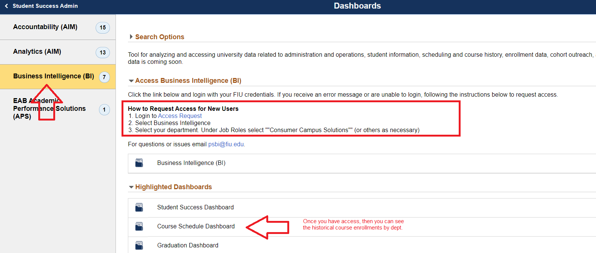

Once you navigate to the course schedule dashboard, select the Historical Course Offering Tab.
Here you will be able to select the filters (term, course, campus, etc) to return the data you need
