- Log in to my.fiu.edu
- Navigate to the Main Menu>Curriculum Management>Instructor/Advisor Information
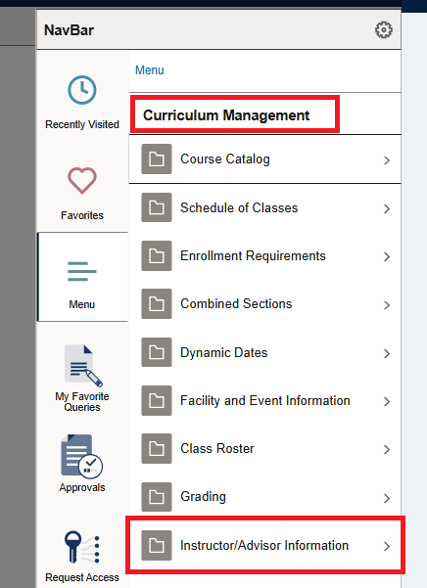
- Select Instructor Schedule
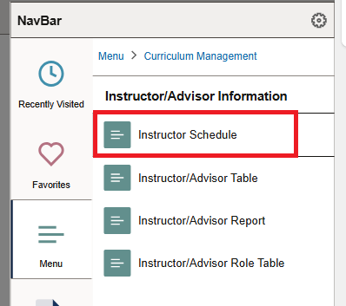

- Enter the TERM and the Instructor’s Panther ID, then Select Search
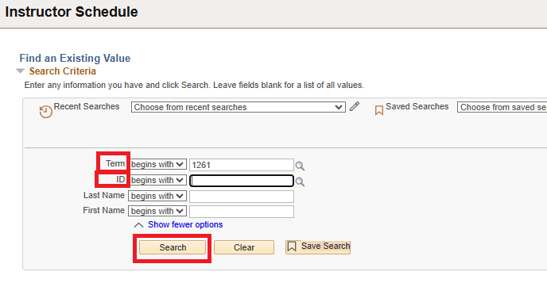

- Review Results
