Florida International University
Class Permission PantherSoft Enhancement

BEFORE – “requisites not met”, “career restriction”, and “consent required” defaulted to yes
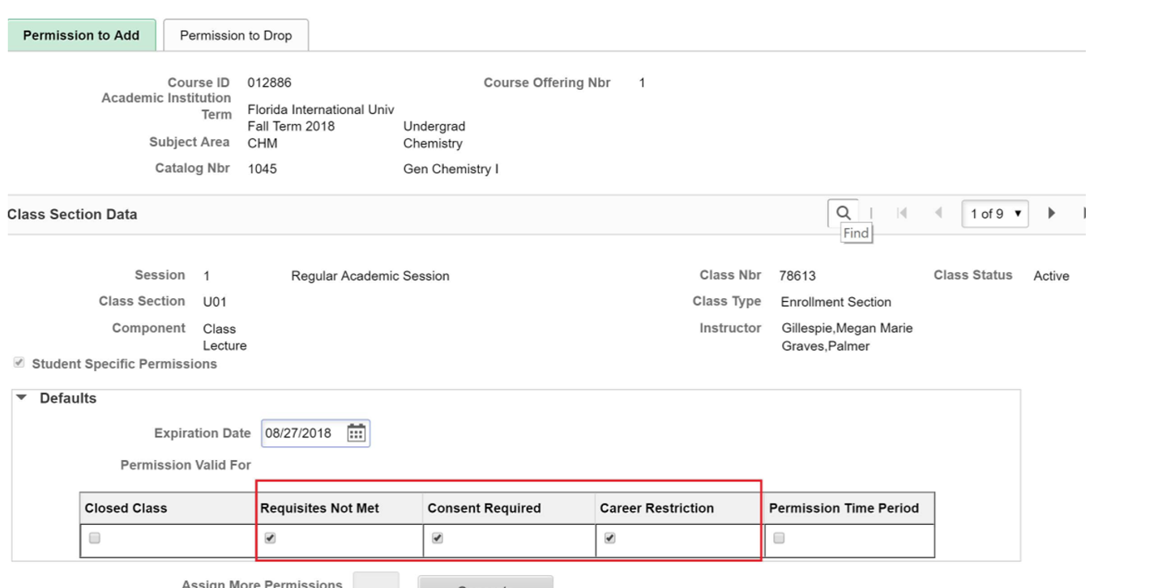

NOW – Only “consent required” is defaulted to yes 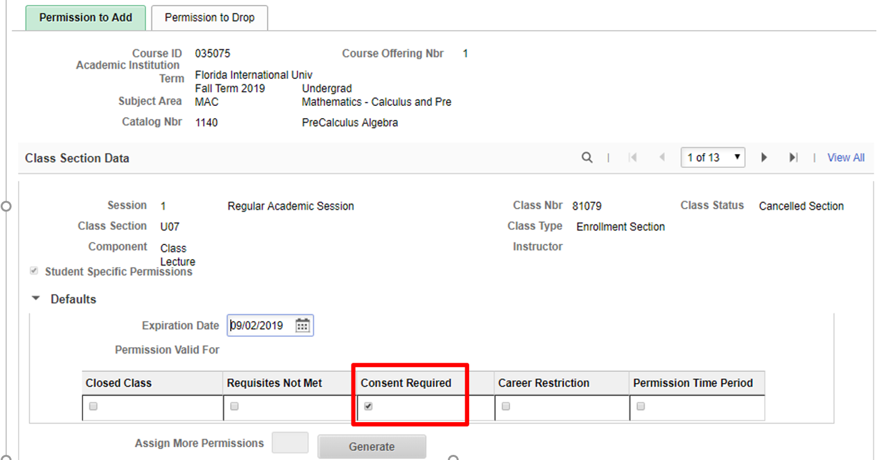

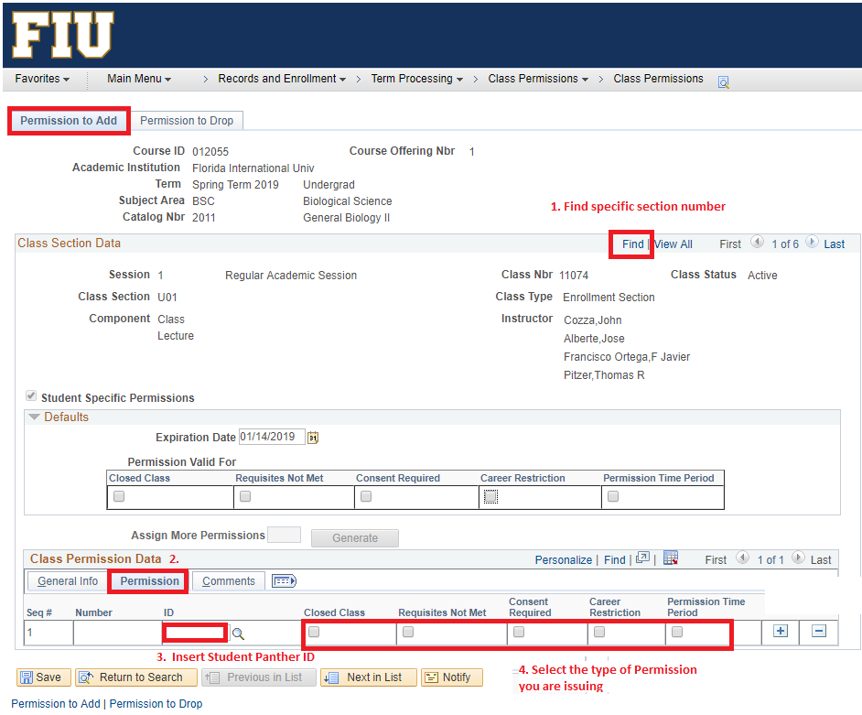
Ensure the proper permission type is selected under Permission Tab for each student.

